Important Points

1. **Scalability**:
   1. When we talk about Scalability in Kafka, it is in terms of how much parallelly we can read and write from a Kafka Cluster.
   2. So, the more brokers we add, then the more parallelly, we can read/write from/to Kafka Cluster.
   3. Scaling out here means to increate reading and writing from/to Kafka Cluster parallelly.
   4. Scaling is possible due to partition of a topic.
2. Two consumers cannot read from the same partition to avoid double reading.

So Maximum number of consumers are limited by the number of partitions.  
**Example**: If we have 10 partitions, then only maximum 10 consumers are allowed.  
 Yes, if we have consumers, then each consumer will consume from two partitions.

1. One broker may have multiple partitions.

1. What is Apache Kafka

1. 
2.   
   **It has following two meanings**:   
   Realtime Stream of Data Pipeline.
3. **Real-time Example**: Smart Meters generating data related data every minute and sending to **Kafka Server**.  
   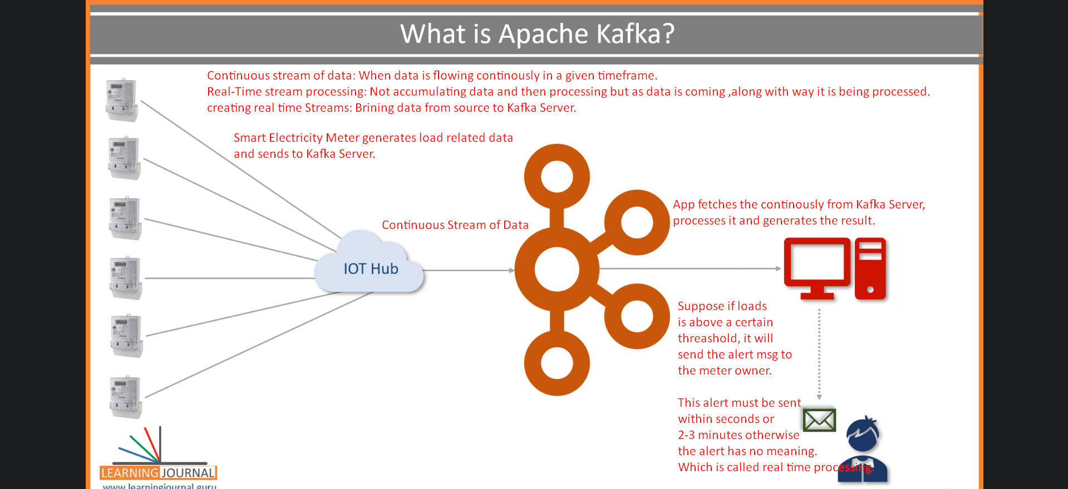
4. 
5. 
6. Apache Kafka adopted **Pub-Sub Messaging System Architecture** and works as an **Enterprise Messaging System**.
7. **Three components of a messaging system** 🡺 Producer(Publisher), Broker, & Consumer (Subscriber).

1. 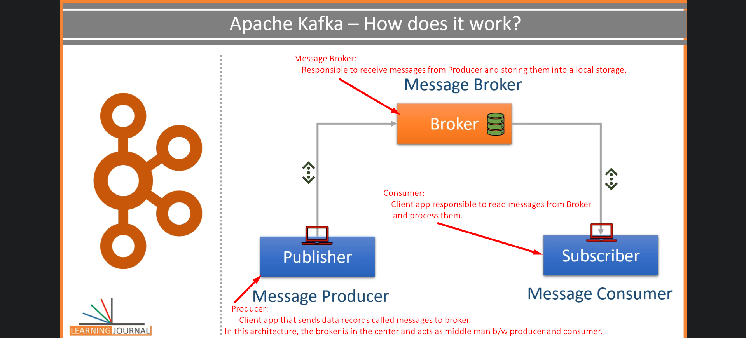  
   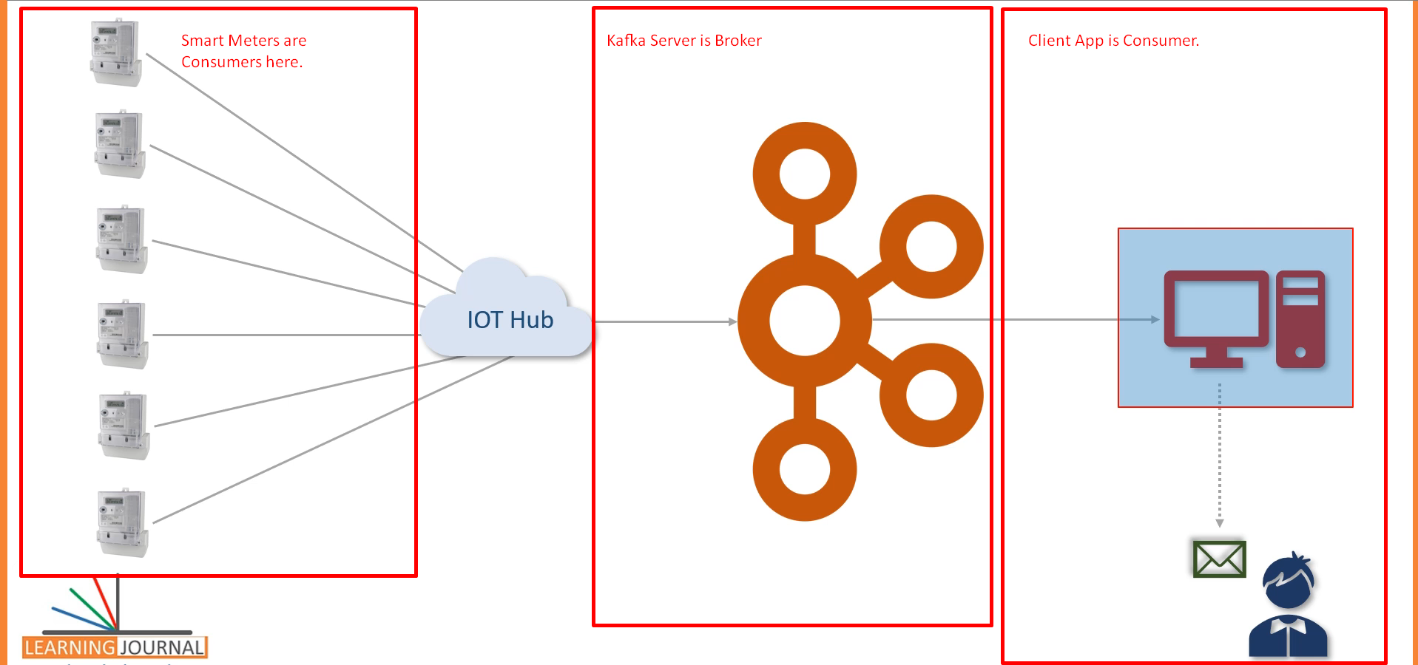

Kafka works as **Pub-Sub Messaging System** where we create a **Producer App** to create and send data **as a stream**.   
We install and configure **Kafka Server** to act as **a message Broker**.  
Finally, we create **consumer app** to process the **data stream** in **realtime**.

1. 
2. Kafka was initially conceptualized and developed at **Linkedin** and later on **open sourced** in 2011 to solve Data Integration
3. 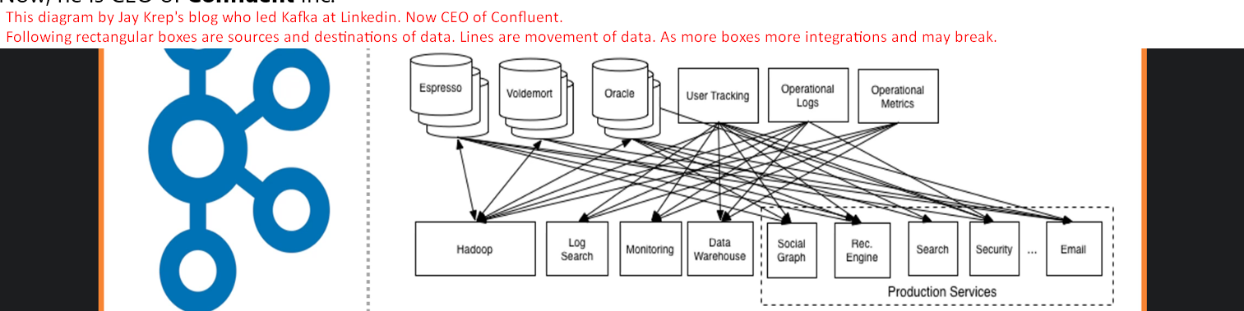
4. 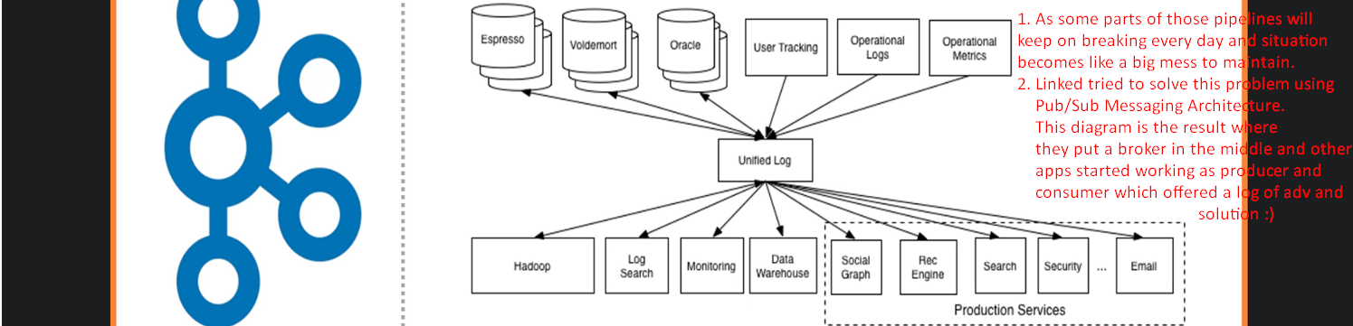
5. 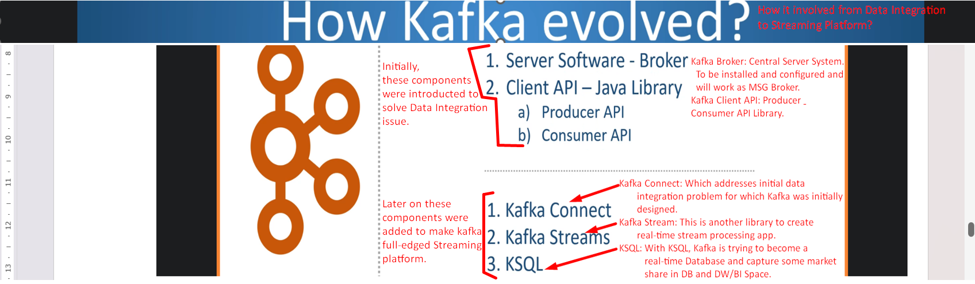
6. 
7. 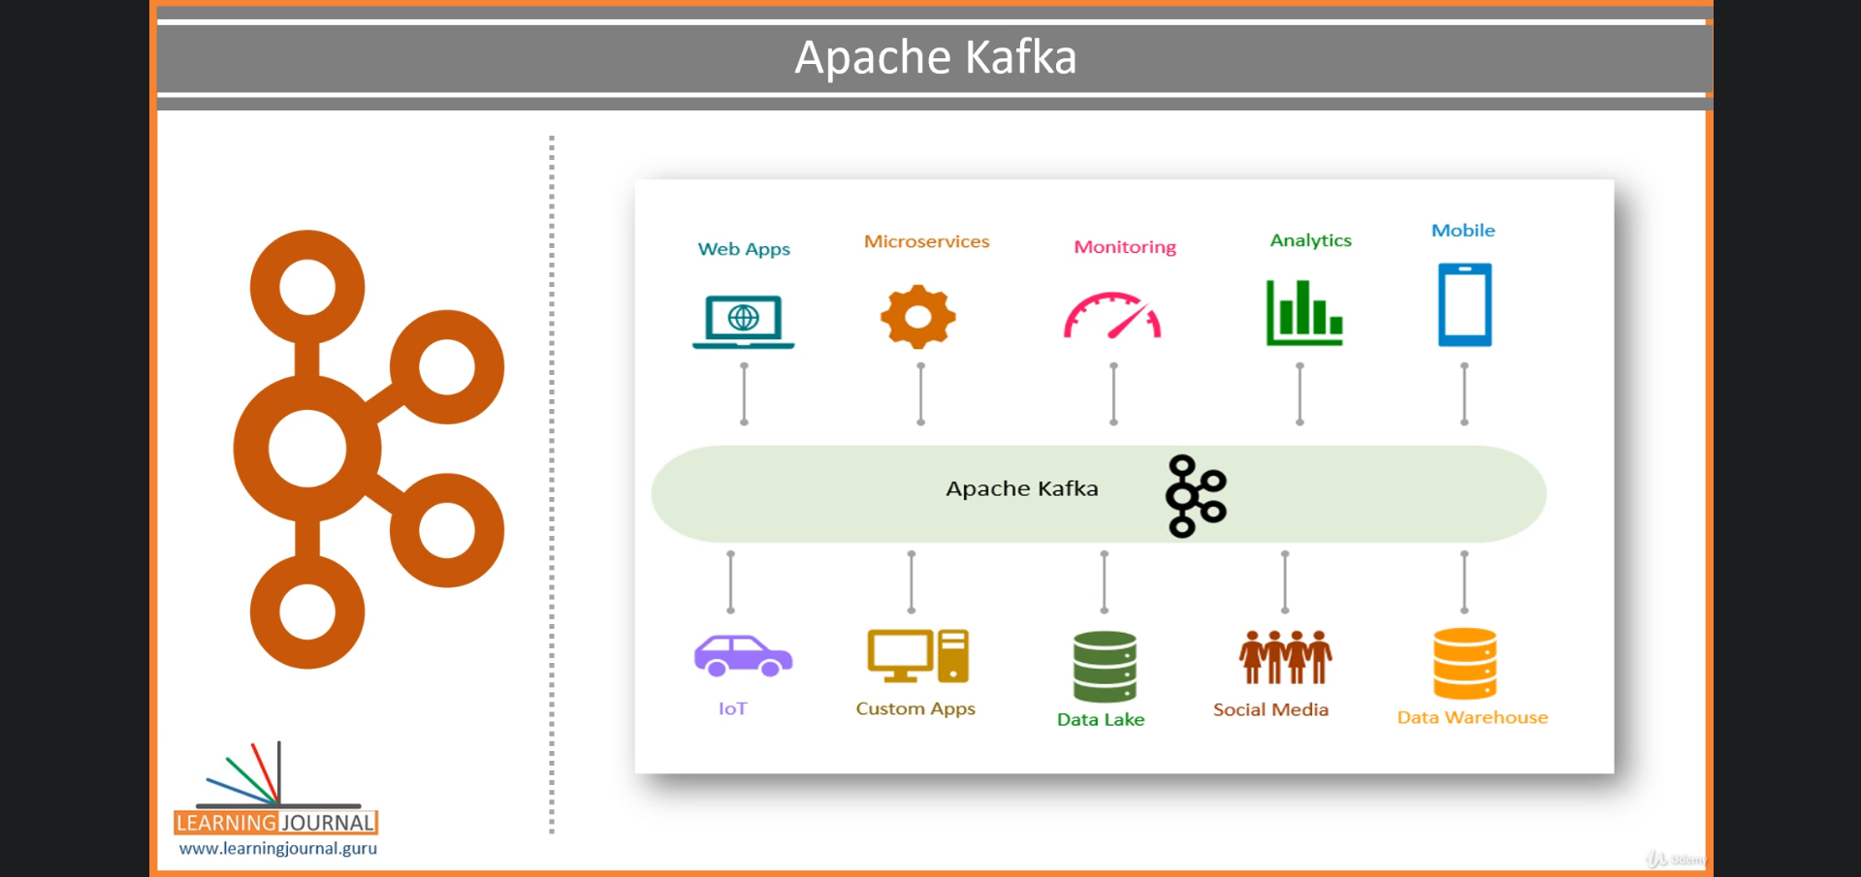

2. Apache Kafka Core Concepts

1. 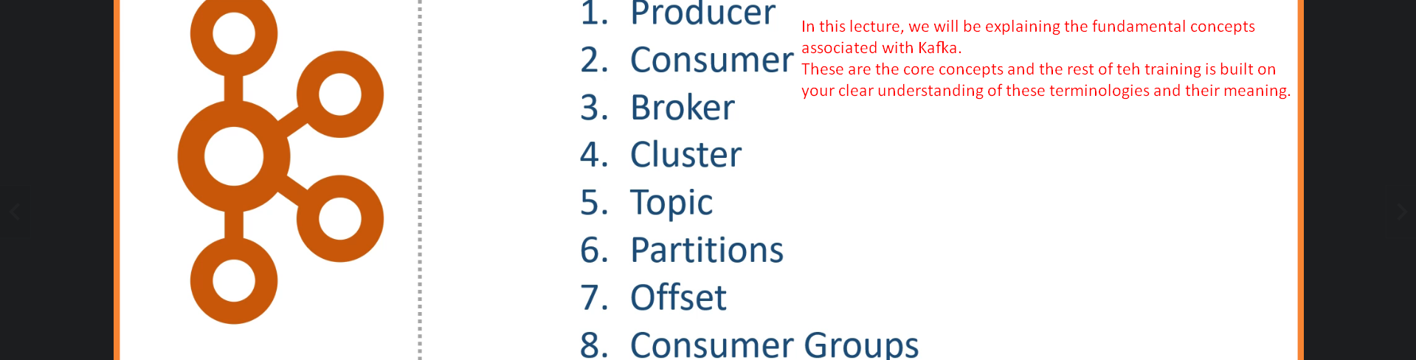
2. Producer is app sending data (msg, msg record) from small to medium sized.
   1. Msg may have any record structure schema but for kafka it is an **array of bytes.**
   2. **Example**:  
      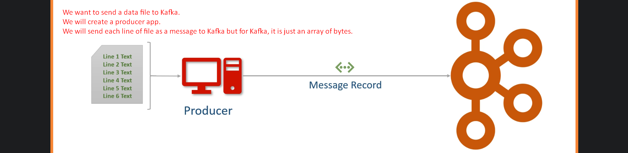  
      Other examples may be like sending a table or result set from a query.   
      So, basically create appropriate Producer App as per your requirement.
3. **Consumer**:
   1. Recipient. Producer doesn’t send directly to consumer but via Broker/Kafka Server. 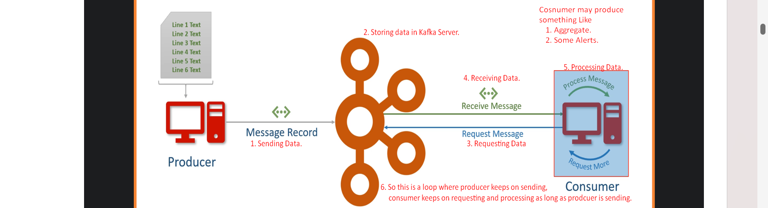
4. **Broker**:
   1. Kafka Server as an agent or a broker to exchange messages.
5. **Cluster**:
   1. Kafka Cluster is a group of computers each running an instance of Kafka Server/Broker for a single purpose.
6. **Kafka Topic**:
   1. **Examples**: Current Load, Consumed Units, Input Fluctuations which one you want.
   2. Arbitrary but unique Name given to a data set. Think like a DB Table Name which is design time decision.
   3. 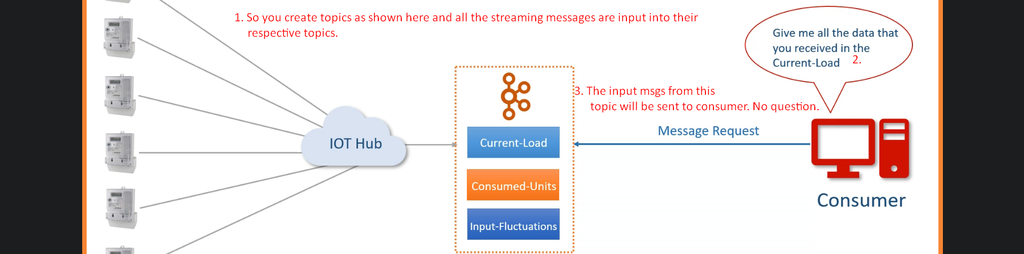
7. **Partitions**: A Smallest and independent portion of a topic
   1. A topic Size may be more than the size of a Kafka Server/Broker.
   2. **Solution**: P1 + P2 + … + Pn = Topic.  
      Where each partition will be assigned to one Kafka Server on a Kafka Cluster. Definitely we need Kafka Cluster.
   3. No of partition is design time decision by an architect.

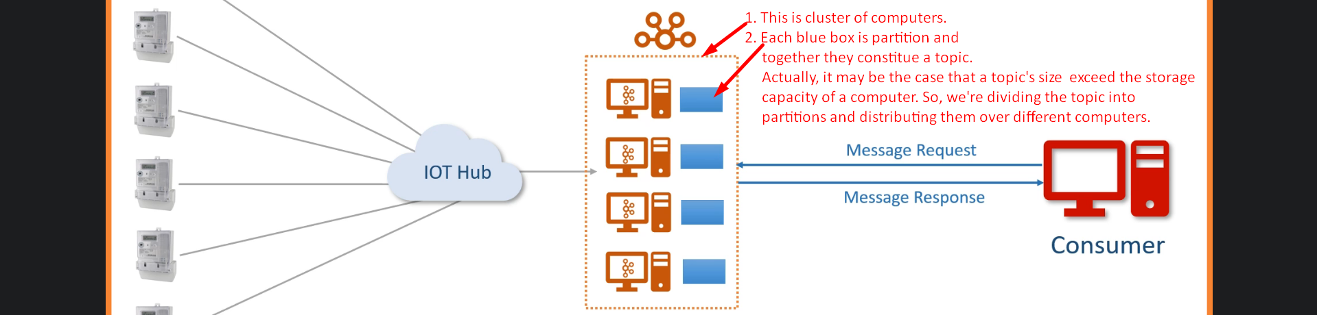

1. **Partition Offset**:
   1. 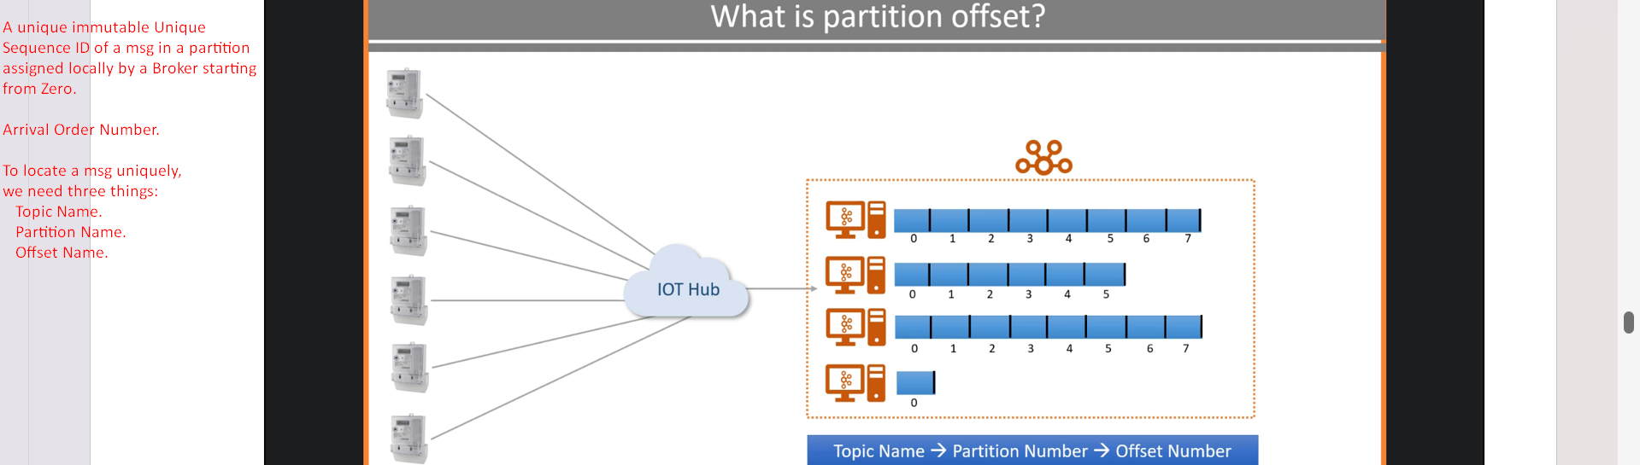
   2. 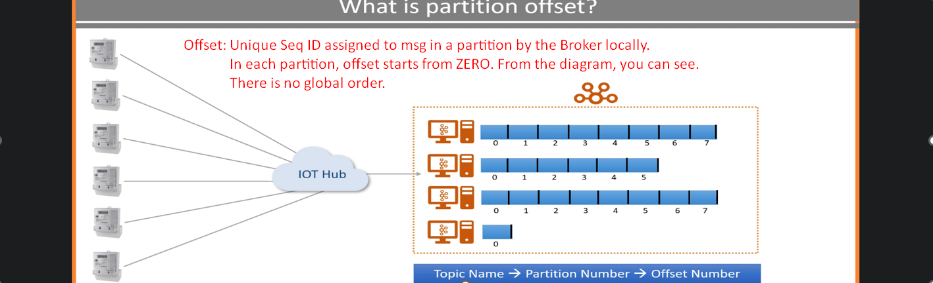
2. **Consumer Group**:
   1. A group of consumers to share a workload. **Purpose** to share workload.
   2. Multiple brokers to share workload when receiving the msgs from a number of producers.
   3. Multiple consumers to consume msgs coming in bulks.  
        
      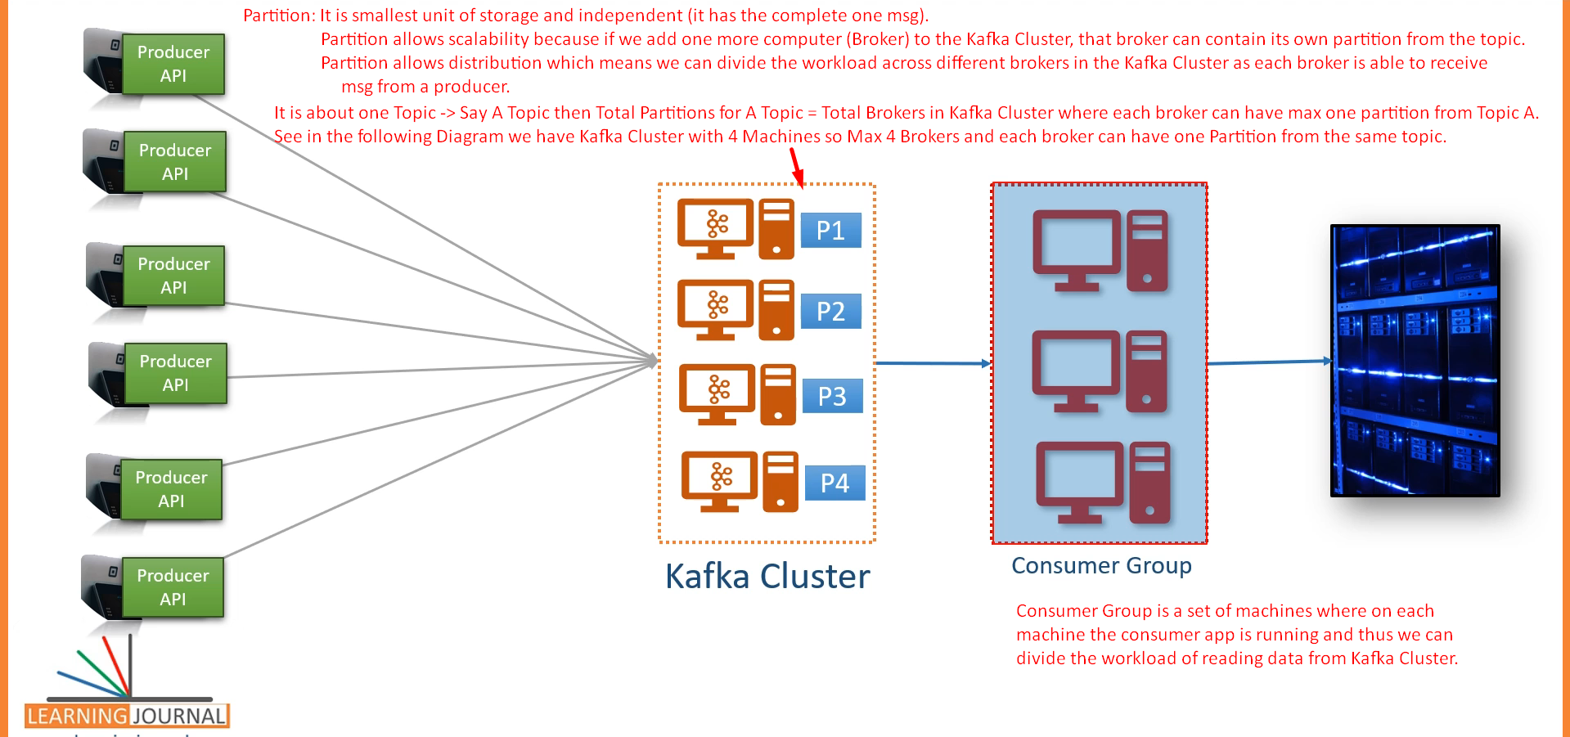  
      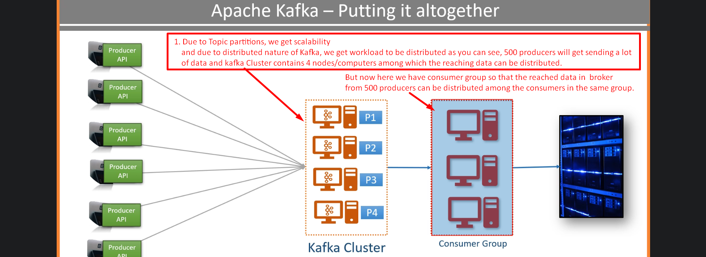

Kafka Connect Core Concepts

Some lectures are skipped. Please complete them.

8. Kafka Quick Start

1. Now we know about 5 components in Kafka  
   
2. **Agenda of this lecture**:  
   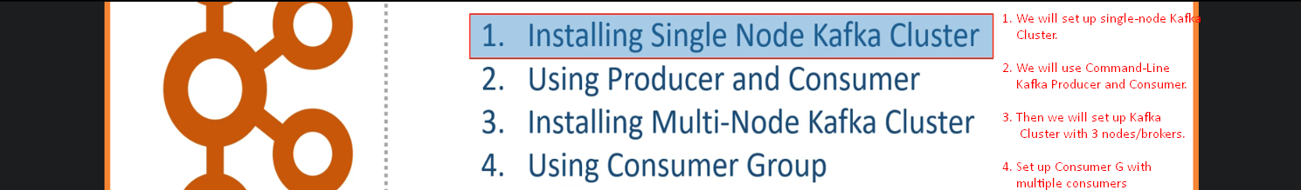
3. Installing Single Node Kafka Cluster
4. **Agenda**: Set up Single Node Kafka Cluster.
5. Skipping some parts. Please read.  
   
6. From above, we will use 2nd option 🡺 Download Apache Kafka Server from Confluent.io.
7. 

As per 2nd option, download Kafka Confluent Community Edition.  
  
  
  
  
  
  


1. How to start Kafka?
2. Starting Kafka is two-Step Process;
   1. **Start 01**: Starting Zookeeper Server.  
      
      1.   
           
         **rem Classpath addition for LSB style path**

**if exist %BASE_DIR%\share\java\kafka\* (**

**call :concat %BASE_DIR%\share\java\kafka\\***

**)**



* 1. **Step 02**: Run Kafka Broker.  
       
     

We created Single-Node Kafka Cluster.

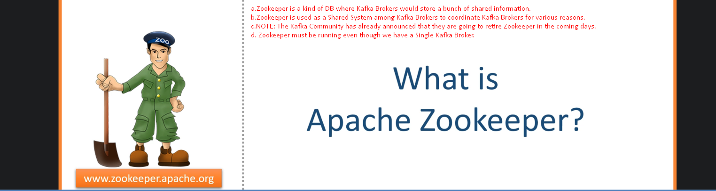

1. Using Command-Line Producer and Consumer
2. 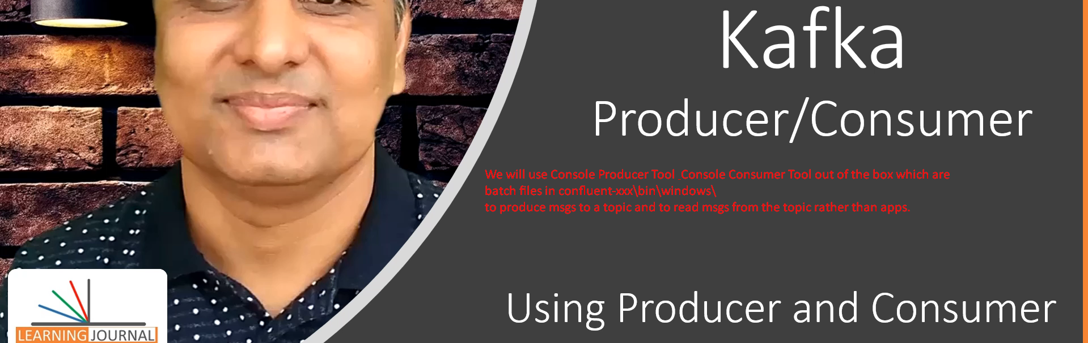
3. 
4. 
5. Sending and consuming Data
6. 1st create a topic using script 🡺   
   2nd Send Data to Kafa Server using script 🡺   
   3rd Consume Data from Kafka Server using script 🡺 



1. When creating topic, need to tell the # of partitions for a topic.  
     
   
2. Command **kafka-topic** options  
   
   1. **--create**: To create a topic
   2. **--partition**: To define partition number.  
      But how to decide the number?  
      
   3. **--replication-factor:** The number of copies for each partition to achieve fault tolerance. Useful only if we have two or more brokers in the cluster.
   4. **--bootstrap-server**: Initial broker network locations from Kafka Cluster for Kafka Clients (Producer & Consumer) to connect initially with Kafka Cluster’s brokers.



1. We will use this script to send data from console to Kafka Cluster.  
   
2. Command to read and send a Data File to Kafka Server.



1. Command to consume msgs from Kafka Server.  
   